For each dataset last column is predicted except from AAPL stock where close price is predicted.

All predictions vs actual graphs show the prediction of the first data point irregardless of horizon

Hyperparameters: lr=0.001, Epochs=100 w/ early stopping, Sequence length=48

Forecast lengths = [1,12,24,48]

MLP ( 2 hidden layers of 256)

AAPL Stock

F=1

Test Loss: 0.0124

Mean Absolute Percentage Error: 7.3916

F=12

Test Loss: 0.0342

Mean Absolute Percentage Error: 12.0139

F=24

Test Loss: 0.0985

Mean Absolute Percentage Error: 19.1886

F=48

Test Loss: 0.3854

Mean Absolute Percentage Error: 31.8671

ETTm1

F=48

Test Loss: 0.4641

Mean Absolute Percentage Error: 37.8475

F=1

Test Loss: 0.0695

Mean Absolute Percentage Error: 15.2678

F=12

Test Loss: 0.1337

Mean Absolute Percentage Error: 21.4892

F=24

Test Loss: 0.1576

Mean Absolute Percentage Error: 23.3858

ETTm2

F=1

Test Loss: 0.0130

Mean Absolute Percentage Error: 8.8466

F=12

Test Loss: 0.0916

Mean Absolute Percentage Error: 28.7356

F=24

Test Loss: 0.1705

Mean Absolute Percentage Error: 42.7802

F=48

Test Loss: 0.5272

Mean Absolute Percentage Error: 64.7698

KAN ( 2 hidden layers of 256, layernorm so don’t need grid extensions)

AAPL Stock

F=1

Test Loss: 0.0162

Mean Absolute Percentage Error: 16.9614

F=12

Test Loss: 0.0281

Mean Absolute Percentage Error: 22.8748

F=24

Test Loss: 0.0288

Mean Absolute Percentage Error: 23.0675

F=48

Test Loss: 0.0239

Mean Absolute Percentage Error: 20.1719

ETTm1

F=1

Test Loss: 0.0616

Mean Absolute Percentage Error: 7.6880

F=12

Test Loss: 0.2760

Mean Absolute Percentage Error: 21.7738

F=24

Test Loss: 1.5039

Mean Absolute Percentage Error: 31.5698

F=48

Mean Absolute Percentage Error: 33.4480

Test Loss: 0.4641

ETTm2

F=1

Test Loss: 0.1882

Mean Absolute Percentage Error: 18.8683

F=12

Test Loss: 0.2251

Mean Absolute Percentage Error: 33.9296

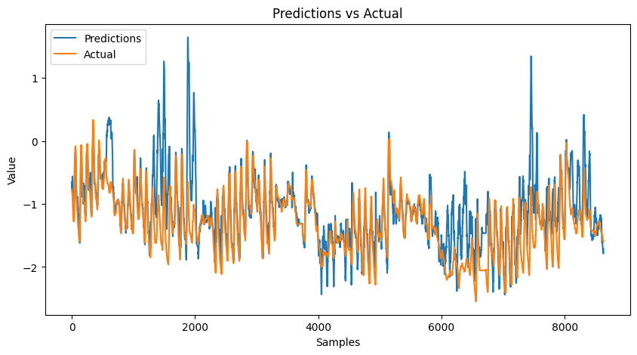

F=24

Test Loss: 2.3131

Mean Absolute Percentage Error: 93.6540

F=48

Test Loss: 1.1406

Mean Absolute Percentage Error: 78.5234

TCN(3 hidden layers, kernel size=3, 256,128,128 channels at each hidden layer)

AAPL

F=1

Test Loss: 0.0011

Mean Absolute Percentage Error: 5.0561

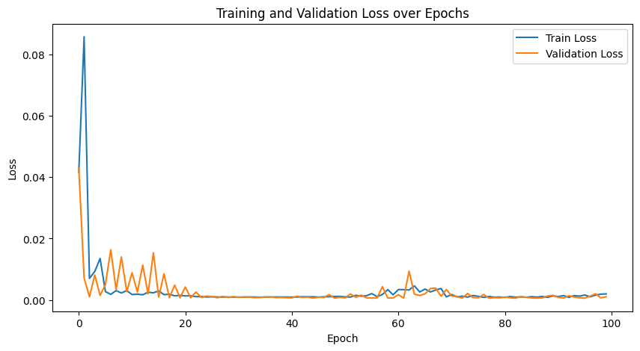

F=12

Test Loss: 0.0091

Mean Absolute Percentage Error: 13.2520

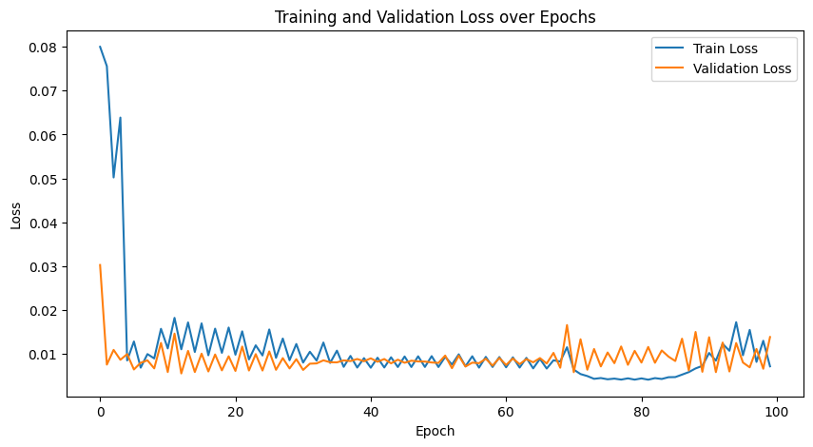

F=24

Test Loss: 0.0261

Mean Absolute Percentage Error: 21.0062

F=48

Test Loss: 0.0737

Mean Absolute Percentage Error: 32.7801

ETTm1

F=1

Test Loss: 0.0109

Mean Absolute Percentage Error: 6.1350

F=12

Test Loss: 0.0659

Mean Absolute Percentage Error: 15.3915

F=24

Test Loss: 0.0726

Mean Absolute Percentage Error: 15.4706

F=48

Test Loss: 0.2304

Mean Absolute Percentage Error: 27.3779

ETTm2

F=1

Test Loss: 76.7480

Mean Absolute Percentage Error: 106.1547

F=12

Test Loss: 96.8810

Mean Absolute Percentage Error: 116.1427

F=24

Test Loss: 123.1123

Mean Absolute Percentage Error: 136.2179

F=48

Test Loss: 180

Mean Absolute Percentage Error: 156.2179

TCKAN(3 hidden layers, kernel size=3, 256,128,128 channels at each hidden layer)

AAPL

F=1

Test Loss: 0.0347

Mean Absolute Percentage Error: 18.6266

F=12

Test Loss: 0.0535

Mean Absolute Percentage Error: 25.9718

F=24

Test Loss: 0.0639

Mean Absolute Percentage Error: 28.8669

F=48

Test Loss: 0.0789

Mean Absolute Percentage Error: 33.5295

ETTm1 (tckan)

F=1

Test Loss: 0.0020

Mean Absolute Percentage Error: 2.8318

F=24

Test Loss: 0.1619

Mean Absolute Percentage Error: 23.1924

F=12

Test Loss: 0.0623

Mean Absolute Percentage Error: 14.6607

F=48

Test Loss: 0.4027

Mean Absolute Percentage Error: 36.6891

Transformer( dmodel=128, heads=8, encoder layers = 4, ffdim=128)

AAPL

F=1

Test Loss: 0.0296

Mean Absolute Percentage Error: 18.6499

F=12

Test Loss: 0.0662

Mean Absolute Percentage Error: 27.5846

F=24

Test Loss: 0.0404

Mean Absolute Percentage Error: 23.0636

F=48

Test Loss: 0.0627

Mean Absolute Percentage Error: 32.0978

KANTransformer( dmodel=128, heads=8, encoder layers = 4, ffdim=128)

APPL

F=1

Test Loss: 0.0493

Mean Absolute Percentage Error: 24.4500

F=12

Test Loss: 0.1964

Mean Absolute Percentage Error: 67.1046

F=24

Test Loss: 0.1194

Mean Absolute Percentage Error: 43.5702

F=48

Test Loss: 0.1308

Mean Absolute Percentage Error: 52.4660